Pattern Trains Revisited

Name:________________________ Partners' Names:_____________________________________
We made pattern trains by starting with a shape – usually a square – and attaching other squares to it in some way. To review pattern trains and introduce the standard equation of a line, work in pairs or groups of three to study “pattern starfish”. Pattern starfish 0 is a plain pentagon. Pattern starfish 1 is a pentagon with a triangle attached. Pattern starfish n is a pentagon with n triangles attached. Always attach the triangles so that exactly one edge of the new triangle overlaps completely with an edge of the previous starfish.

- Draw some pattern starfish below. Then make a table of the lengths of the perimeters of pattern starfish 0 through 5.

- Look at the pattern starfish drawn by your partner or by the groups next to you. There's more than one way to draw pattern starfish 3, 4, and 5! Do differently drawn pattern starfish with the same number have different perimeters? Can you explain why or why not?

- What number do you add to the perimeter when you add 1 to the number of the starfish?

- Use your answer to the previous question to predict the perimeter of starfish 6, 8, and 10. Write your predictions below.

- Find a function relating the number n of the starfish to its perimeter p. If you get stuck, ask a neighboring group to help.

- Use your function to predict the perimeter of starfish number 100.

- For the function you found above, which variable is the independent variable (the one you control)? Which is the dependent variable (the result you study)?

- Use the table of values you found in problem 1 to sketch a graph of your functionThe value of the independent variable gives the position of a point along the horizontal “x”-axis. The value of the dependent variable gives the vertical position of the point above or below the x-axis.

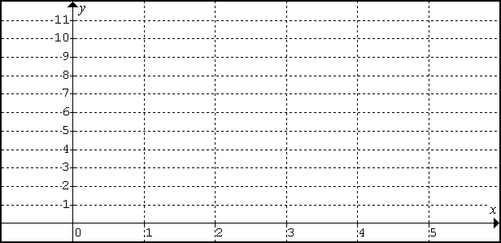
- Where does the graph of your function cross the y-axis?

- How is your answer to the previous question related to the shape of starfish 0?

- When the independent variable (x-value) increases by one, what is the change in the y-value (the value of the dependent variable)?

- How is your answer to the previous question related to the process of adding a triangle to a starfish? (Look back at question 3 if you get stuck.)

Mathematicians spend a lot of time studying how the value of the dependent variable changes as the independent variable changes – this is the basic idea studied in beginning calculus and in many courses that require calculus. Plenty of other people are also interested in this sort of thing – imagine if you could figure out how the value of a stock on the stock market was going to change as the day of the year changed!

To help describe this change, mathematicians (and others) use the idea of a “slope”. The slope of the line you graphed is given by its “rise” divided by its “run”; in other words, by choosing points (x1, y1) and (x2, y2) on the graph and then calculating (y2 – y1)/(x2 – x1).

- What is the slope of the line you graphed?

- How is your answer to question 13 related to your answers to questions 12 and 3?
- “A pattern train made with train 0 being a square (perimeter 4) and increased by adding more squares to the train (perimeter 4, with 1 edge overlapping the old perimeter, so adding 2 to the perimeter each time) gives rise to the function: p = 4 + 2n.” Write a similar sentence describing pattern starfish:

- Use the ideas in problem 15 to create a pattern thing with the following equation:

- When you finish, write the name of your pattern thing, the shape of the starting polygon, and a description of how you increase the “length” of your pattern thing below. Then write your equation and solution on the board.

