Terra Lycos - Latin America-

At a Special Meeting for Lycos stockholders held on October 27, 99.4 percent of votes cast supported the merger, clearing the way to finalize the combination of Terra Networks, S.A. and Lycos, Inc. The new company Terra Lycos is a global Internet network operating in 41 countries in 20 languages, reaching 91 million unique monthly visitors worldwide (see exhibit 1 for the company stock price and exhibit 2 for a list of all the companies in the Terra Lycos network). The company is created with the mission of becoming “the most visited online destination on the world”. Terra Lycos headquarters are in Barcelona, Spain but the operations headquarters are in Waltham, MA. Terra Lycos CEO is Bob Davis, former Lycos’ CEO (see exhibit 3 for Terra Lycos management team).

The definitive agreement on the merge was reached On May 16. At that time the acquisition was valued at $12.5 billion when it was first announced, but the value of Terra Networks' American-listed shares plunged in recent months, cutting nearly $7 billion off the buyout price. Terra Lycos will launch with approximately $3 billion in cash, making it one of the world’s best capitalized Internet companies and is expected to have pro-forma CY2000 revenues of approximately $500 million.

Terra Lycos aggregates services and local and international content from leading providers from around the world, and provides online advertising and marketing, e-commerce, and other Web services. Terra Lycos will hold the leading position in four of its eight primary markets. The company will lead the market in Canada, Korea, Latin America and the U.S. Hispanic market. Terra Lycos will be number two in Asia including Japan, number three in Europe, and number four in the United States. Moreover, Terra Lycos provides Internet access to more than five million customers throughout the world.

The merger was sound for both Terra and Lycos’ board. Both companies complemented each other well and joining forces would create a global Internet player that could improve both companies market position. The company will also leverage its important partners in this combination. Bertelsmann, the third largest media company in the world, and Telefonica, terra’s major stockholder, a leading telecommunications company, will provide content, commerce and connectivity assets, providing a major market differentiator. The merging companies had different culture and business models. For the merger to be successful, Terra Lycos management team must overcome those differences.

Lycos and Terra had different geographic focus. However, Latin America was the only geographic overlap. At the time of the merger, Terra had a strong presence in the region and a content-based model; Lycos, on the other hand, was creating the Latin America division. After, the merger, on the implementation phase, Terra Lycos had to define its strategy for Latin America and as Matt Martinez, Director for Lycos Latin America points it out, it’s not an easy task: “Terra Lycos focus is on profit. The financial markets are asking for it. For the Latin America Region we ask ourselves the same question as for every region: which model will produce higher profits? How do we create new sources of revenue? . But we also ask some new questions, unique for the region: What do we do with the two brand names? How should we organize for the region? Is a global model applicable to the region?”

Lycos, Inc. (www.lycos.com)
In 1994 Carnegie Mellon researcher Michael Mauldin devised a Web search engine and, using a name derived from Lycosidae (the Latin name for the predatory wolf spider), dubbed his invention Lycos. After purchasing the technology, CMGI subsidiary CMGI@Ventures formed Lycos, Inc. in 1995 and appointed Robert Davis as CEO. Wasting no time, Lycos went public in April 1996 and gained more exposure the following year when it became one of the search services accessible from Netscape's search and directory page.

On June 1997, Lycos and Bertelesmann AG created Lycos Europe, a localized version of Lycos site throughout Europe. Lycos Europe gets nearly 65% of sales from advertising; e-commerce and licensing make up the rest. It has been expanding by snapping up other portals, including Scandinavia's Spray and France's MultiMania.

Lycos expanded to Japan in 1998 by teaming up with Sumitomo. In the same year, the company acquired Tripod (home page building – www.tripod.com), wisewire (directory building) and WhoWhere (directory services – www.showhere.com). The company expanded to Korea the following year, forming a joint venture with Mirae Corporation. Still in 1999, Lycos beefed up its Asia presence with the formation of Lycos Asia with Singapore Telecom and acquired Sonique (Internet music distribution – www.sonique.com), Quote.com (financial information web site – www.quote.com) and Gamesville.com (interactive entertainment company – www.gamesville.com).

In 2000 Lycos launched Sympatico-Lycos, a Canadian business-to-consumer Internet portal, in partnership with Bell Canada. It also began offering free Internet access, created LycosLabs, which will finance Internet startups, announced a joint venture with Quack.com to develop a voice-accessed portal, and launched a co-branded automotive Web site with Autoweb.com (Lycos took a 10% stake in Autoweb).
Prior to the merger, the company's Lycos Network was visited by nearly 31 million people each month and featured services such as Web searching, chat rooms, e-mail, online shopping, news, auctions, streaming video programming, and homepages. The company also offered free Internet access. Nearly 70% of Lycos' revenue came from advertising; the company also generated revenue through e-commerce agreements with companies such as Barnes & Noble and AT&T, as well as through licensing agreements with companies including IBM and Packard Bell NEC.
At the time of the merger, Lycos had about 900 employees in the United States and was profitable from on the fiscal year that ended August 2000. Revenues for the fiscal year were $300 millions.

Lycos has implemented a co-brand strategy with content providers. Lycos website routes traffic from content providers and shares advertisement revenues. Lycos has developed 57 co-brand partnerships. This strategy allows Lycos to provide the required content without incurring in the costs of developing it. The strategy has proven to be effective to Lycos. The content resides in the developer network and it’s just adjusted to the Lycos format. Users have the same Lycos experience but actually the content resides in the content provider network. Both Lycos and the content provider share advertisement revenues.

Lycos Latin America

Lycos focus on Latin America started on Late 1999. Until the time of the merger Lycos Latin America grew to 20 employees, with the region headquarters on Miami, FL. Lycos gained presence in Argentina, Brazil, Colombia, Chile, Mexico, Peru and Venezuela (see Exhibit 4 for Lycos website in Latin America). Lycos has implemented its global strategy in the region. Though Lycos Latin America has only been up for a few months, Lycos closed significant co-brand deals in Latin America countries.

Terra Networks (www.terra.com)
Telefónica, the dominant telephone company in Spain and in Latin america, split off its Internet activities in late 1998 as Telefónica Interactiva. The unit took control of Internet companies in which Telefónica had stakes, as well as other Spanish and Latin American Internet companies, including Spanish portal Ole; Internet companies ZAZ (Brazil), Infovia (Guatemala), and Infosel (Mexico); and several companies belonging to Telefónica subsidiaries in Chile and Peru. The company “Telefonica interactive” changed its name to Terra Networks in 1999, and Telefónica floated a 30% stake in an IPO. Terra launched a portal in the US with IDT in 2000 and bought a 30% stake in DeRemate.com, a provider of online auctions in Latin America.

Telefonica rolled out Terra by buying and integrating existing portals and Internet service providers in Portuguese and Spanish speaking countries. Terra Networks became the world's leading provider of both ISP services to residential and small office (SOHO) clients and content for the Spanish-and Portuguese-speaking markets. Terra kept the original technologies in each country and the content. Terra develops its own content and also buys content form third parties in long exclusive contracts.

Terra acquired portal Chevere in Venezuela and “La Ciudad” in Colombia, during 2000, consolidating in the Region. Terra has also partnered with Telefonica Moviles to create Terra Mobile, a wireless portal for the European and Latin America region. Terra also teamed with Lotus to develop Instanterra (instant messaging solution).

The Company operated in 16 countries throughout the world: Spain, Brazil, Mexico, Chile, Peru, Uruguay, Guatemala, Argentina, Costa Rica, Venezuela, Colombia, El Salvador, Honduras, Nicaragua, Panama and the United States (see exhibit 5 for Terra’s websites in Latin America). Before the merger the company employed around 2000 employees; around 60% of Terra’s workforce was located in Latin America. In the United States alone, Terra had 35 employees developing content. For the six months ended 6/00, revenues totaled 82.5 million euros. Net loss totaled EUR267.3 million.

Terra acquired major portals and ISP in each country it operates (such as Ole in Spain, Gauchonet in Argentina and Infosel in Mexico). Terra has kept the technology and some legacy in each country and it has adopted a country by country strategy (i.e. specialized technology and content in each country). Thus, Terra sites are different in each country (see exhibit 5 for terra or visit the links www.terra.com.mx, www.terra.com.br and www.terra.com).

Terra Lycos: Latin America challenges

As the integration of the two companies took place, Lycos and Terra’s management faced difficult issues in Latin America. Management needed to take a decision on two important issues. Management had to decide the brand strategy for the region. And the best model to apply in the region. Matt Martinez, Lycos Director of Latin America, expressed it: “We will not have difficulties in the integration of Terra and Lycos for the region. Lycos Latin America is only 20 people. There should not be problem in the organization structure. Terra can clearly absorb us in the organization. The challenges for us are the strategic decisions and obtain quick financials results.”

Terra Lycos had two websites and two brand names for Latin America. On one hand, there was the Terra strong brand name. And on the other, there was this international Lycos brand name associated with the Lycos network and other portals such as Tripod and HotBot. As Matt Martinez, Lycos Director for Latin America, pointed it out: “We have two portals running now. Should we kill one of the websites and direct all the traffic to one? Would traffic move to the other website or to a competitor, if we kill one of the websites? Are we duplicating efforts by having the two websites? Keeping the two brands might not be the best financial decision because increases the operating costs. But if we kill one of the websites, would we be able to transfer the revenues?”.

Terra has implemented a Local strategy and Lycos a regional one: Terra Mexico website is different from that of Terra Argentina. Terra acquired different web sites in each country and the legacy remains in each of the Terra’s websites. On the other hand, Lycos implemented a standard website for each country, giving the same global look to the website, though the content is specialized for each country. Matt Martinez explained it: “Terra’s websites change considerably from country to country. Terra offers different experiences according to the country. Lycos offers one set of services for the whole region, sharing technologies, content and resources. Again, killing one of the websites would be a decision for one of the two models”.

Lycos did not create content itself. Lycos had relationships with content providers and implemented the co-brand strategy in the region. Terra workforce actually developed content or outsourced in expensive long contracts. In Matt words: “Though content providers are not so common in Latin America as they are in the United States, Lycos was able to direct third party content to its site. Terra has a different model. It actual develops content. The model may work better in the region and may at the end of the day attract more page views and hopefully higher revenues. The model is riskier and margins might decrease. The focus of the Terra Lycos is in profitability. Which model will produce higher revenues and higher profits? ”.

Terra Lycos has become a major player in the global Internet with presence in 41 countries. Latin America is a major part of Terra Lycos global reach, giving Terra strength in the region. Terra Lycos must define a strategy for the region. Is it sustainable to have strategy for Latin America different from the global one? Should Terra Lycos pursue a global brand strategy or focus the brand or each region? Terra Lycos’ challenges are clearly strategic. For the merger to be successful, Terra Lycos’ management must define the issues.

Study Questions

In summary, prepare to discuss answer to the three main questions:

- Compare and contrast Terra and Lycos global strategy. What should the global strategy be? How can Terra Lycos achieve and accelerate global profitability?

- What should Terra Lycos model be for the Latin America region? Is it possible that the model for the region is different from that of other places in the world?

- What should Terra Lycos do with the brand in Latin America? What implications would Latin America brand strategy have in the global strategy? What should Terra Lycos do with the websites in Latin America?

Exhibit 1

Terra Lycos stock chart as of 12/12/00

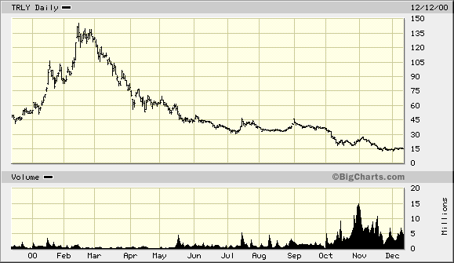

Terra Lycos stock price compared to Yahoo stock price (YHOO) as of 12/12/00

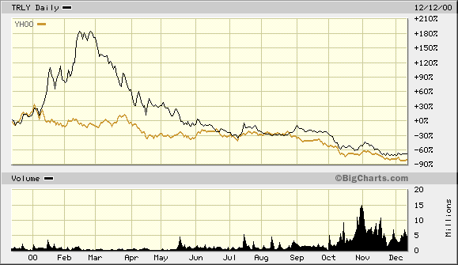

Terra Lycos performance compared to that of Nasdaq as of 12/12/00

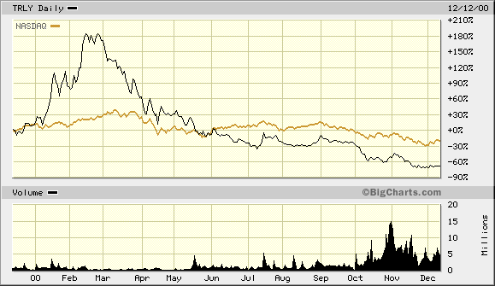

Exhibit 2

Terra Lycos network of companies
Terra.com (www,terra.com)
Terra's Portals offer users across the whole Spanish- and Portuguese-speaking world the widest variety of local and global content and services. Terra's success lies in its ability to satisfy the needs of both dial-up and broadband users, excelling at developing a state-of-the-art live entertainment and multiplatform content
Lycos.com (www.lycos.com)
Lycos.com, a leading portal, offers Internet users a fast, easy and efficient way to make sense of the Internet and manage its vast resources. It combines leading Web search and navigation resources, deep content in vertical areas, communications and personalization tools, and a complete shopping center.
AnimationExpress.com (www.animationexpress.com)
Animation Express is an entertainment destination featuring some of the best animations on the Web. The site features a range of animation styles produced by amateur and professional artists from all over the world.
Angelfire.com (www.angelire.com)
Angelfire makes building homepages simple, giving users a centralized file manager and their choice of a one-step HTML wizard or an advanced editor for direct control. Angelfire focuses on the homepage building experience, rather than communities and content, and provides users with a variety of tools and utilities to publish great pages.
A Tu Hora (www.atuhora.com)
Atuhora.com is an e-commerce site launched in conjunction with Telepizza. The site offers delivery of convenience products such as books, disc, drinks, food and beverage, etc. within one hour to consumer homes.
Gamesville.com (www.gamesville.com)
Gamesville.com produces the Web’s leading interactive entertainment community where members compete for prizes by playing massive multi-player real-time games and is consistently named by Media Metrix as one of the "stickiest" sites on the Internet. Gamesville’s unique approach to interactive entertainment enables thousands of registered contestants to simultaneously vie for prizes in unique, proprietary live games such as poker and other card games, sports, trivia, and bingo.
HotBot.com (www.hotbot.com)
HotBot.com is an award-winning smart, sophisticated search engine with more than 40 tools to help users better articulate their searches and get relevant search results quickly and easily
htmlGEAR.com (www.htmlgear.com)
htmlGEAR offers Web publishers at every skill level a fast and easy way to add compelling and interactive content to their sites. The professional Web add-ons, or Gears, can be used out of the box to easily add an instant upgrade to a home page or be customized or more tightly integrated into a commercial or professional Web site.
Invertia.com (www.invertia.com)
Invertia.com is a financial portal offering global solutions for personal finance with real-time information and tools. It has presence in Argentina, Chile, Mexico, the U.S., and Venezuela.
Lycos Zone
Lycos Zone is a free, engaging and safe online haven for children featuring educational content, fun and games and homework resources. Lycos Zone offers children, teachers and parents the resources they need to explore the world from their PC.
Matchmaker.com (www.matchmaker.com)
Matchmaker is the leading online community enabling secure connections between people with similar interests and needs. Looking for a lifetime lover, a weekend workout partner or a local wine connoisseur, Matchmaker.com is the place to meet all types of people across the world. Matchmaker.com has created a global constellation of city-centric and lifestyle specific communities.
Quote.com (www.quote.com)
Quote.com brings Wall Street-quality information, tools and trading capabilities to independent investors. Quote.com is one of the Internet’s leading providers of streaming quotes and one of the top financial information sites on the Web.
Rumbo.com (www.rumbo.com)
Rumbo is a travel portal that provide the ability to research and purchase flights, hotels, rental cars and vacation packages in real time. This Web site provides users with news articles and in-depth profiles and other information about travel destinations.
Sonique (sonique.lycos.com)
Sonique is one of the most popular audio players, supporting many audio formats including MP3 and is consistently in the top five of the most popular downloads on www.downloads.com. The free audio player technology decodes music files and formats them to be played from the desktop.
Tripod.com (www.tripod.com)
Tripod offers premier, easy-to-use personal-publishing tools and services making it fast, fun and easy for members to build professional-looking homepages, whether they are beginners or experienced users.
Web monkey.com (hotwired.lycos.com/webmonkey/)
One of the first sites written by Web developers for Web developers, Webmonkey is the comprehensive source of information for professional and amateur Web enthusiasts, offering daily articles and technical updates, as well as an archive of more than 200 features and tutorials.
Whowhere.com (www.whowhere.lycos.com)
WhoWhere.com provides a variety of comprehensive directory services that make it easy to find people on the Internet. The directories include E-mail Address Lookup, Phone and Address Lookup, Personal Home Page Lookup and People in U.S. Government.
Wired News (Wired.com)
Launched in November 1996, Wired News quickly rose to become an essential source for daily news and analysis of the technologies, companies, and people driving the information age.
Lycos Ventures
The Lycos Ventures investment strategy is simple: Fund early-stage companies with the foresight and the product to make the Internet more interesting, more useful, faster, and better. In addition to capital, we can contribute distribution and co-branding via the Terra Lycos network of Web properties, which receives 91 million unique visitors each month. This helps our portfolio companies build value, visibility, and branding power more rapidly.
LycosLab
LycosLabs is Boston's unique full service business incubator that offers entrepreneurs early stage funding, resources, and guidance based on real world Internet experience. Located in the western suburbs of Boston, LycosLabs offers New England and Mid Atlantic entrepreneurs the opportunity to be one of a very select group of companies that will reside on our campus, with our team that has thousands of man-years of highly relevant Internet experience.
From strategy, marketing and corporate development to operations and international deployment, LycosLabs harnesses the experts who have built Lycos into one of the world's largest and most profitable networks of Web destinations. E-commerce, infrastructure, technology, and viral applications are a few of the areas that LycosLabs will consider for investing and active business acceleration. We look forward to reviewing your business plan.
Exhibit 3

Terra Lycos’ management team

Joaquim Agut
Executive Chairman
Joaquim Agut serves as executive chairman of Terra Lycos and is responsible for the strategic direction of Terra Lycos. Prior to the combination of Terra and Lycos in October 2000, Agut was chairman of Terra Networks.
Prior to joining Terra, Agut was leader of the European Corporate Executive Council (CEC) of General Electric (GE) and was the first executive of General Electric in Europe. At General Electric, Agut previously held the roles of vice president and general manager of marketing and sales, president and CEO of GE Power Controls, and GE national executive for Spain and Portugal and chairman of the Pan European GE Quality Council.
Agut has also been active in the local and national business community, responsible for Spain’s industrial electronic sector integration in the EEC. In 1984, he was awarded the Young Businessman of the Year Award from a leading Spanish Economic magazine.
Agut earned a bachelor of science degree in electrical engineering from the University Politécnica de Catalunya in Barcelona, Spain, and a MBA from IESE at Universidad de Navarra.

Robert J. Davis
Chief Executive Officer
Robert J. Davis serves as chief executive officer of Terra Lycos and is responsible for the day-to-day operations of Terra Lycos. Prior to the combination of Terra and Lycos in October 2000, Davis was president and chief executive officer of Lycos, Inc., and was Lycos’s first employee in June 1995.
Davis transformed Lycos from an Internet search engine to one of the most powerful Internet hubs and media companies worldwide. In just five years, Davis led Lycos from a company with $2 million in venture capital to a multi-billion dollar business. Under his leadership, Lycos jumped from the fastest IPO in Nasdaq history, a mere nine months from inception to offering, to an esteemed member of the Nasdaq 100. Through a string of strategic partnerships and investments along with eight major acquisitions, Davis led Lycos in developing the Lycos Network, a pioneering Web media model that delivers mass reach and diversity of audience and programming.
Davis holds a bachelor of science degree, summa cum laude, from Northeastern University and an MBA, with high distinction, from Babson College. He also received an honorary Doctor of Commercial Sciences from Bentley College in May, 1999, and an honorary doctorate from Northeastern University in June, 2000. In addition to the Terra Lycos board, he serves on the board of directors of several other public and private sector entities. Davis is also co-chairman of Massachusetts E-Government Task Force, formed to improve and expand the State's e-government capabilities.

Abel Linares
Chief Operating Officer

Abel Linares serves as chief operating officer of Terra Lycos. Prior to the merger of Terra and Lycos in October 2000, Linares served as chief executive officer of Terra Networks.
Linares was appointed CEO of Terra Networks, S.A. in February 2000. At Terra, he helped the company to achieve a 448% growth in subscribers, a 550% in advertising and 500% in e-commerce revenues respectively from June 1999 to June 2000. During this period Terra launched operations in Venezuela, Colombia, El Salvador, Guatemala, Costa Rica, Nicaragua, Honduras, U.S. Hispanic and the Caribbean region. Linares played a key role in the transactions involving De Remate, Uno-e, Tu Ciudad, IDT, Ifigenia, the JV Terra Mobile, A Tu Hora, Motor Press and Meta 4, positioning the company as the undisputed leader in the region.
In January 1999, he was appointed board member of TPI-Páginas Amarillas and was responsible for it’s IPO. TPI experienced a 350% revalorization in the first six months of trading, reaching a market capitalization of US$ 6.3 billion. In 1998, Linares was appointed board member of Telefonica Centro America, as well as president of Telefonica El Salvador. Under Linares, as general subdirector of Telefonica International, Telefonica entered the market as a start-up, and within six months held the world’s highest market share in mobile phones and international long distance benefits. In 1994, Linares joined TPI as general manager, responsible for 600 sales persons. Following this period, he was appointed general subdirector of sales and customer services of Telefonica España, directly responsible for US$ 6.4 billion in sales, 12 million clients and 11,000 employees. He has played a key role in the liberalization of the Telecommunications Market in Spain.
Between 1984 and 1994, Linares held the position of director of sales and marketing in Prime Computer and Computervisión, American multinationals, leaders in the information technology sector, CAD-CAM/CAE/GIS, and consulting aimed to reengineering processes and reduction of time to market.
Linares holds an Aeronautic Engineer degree.

Exhibit 4

Lycos Mexico

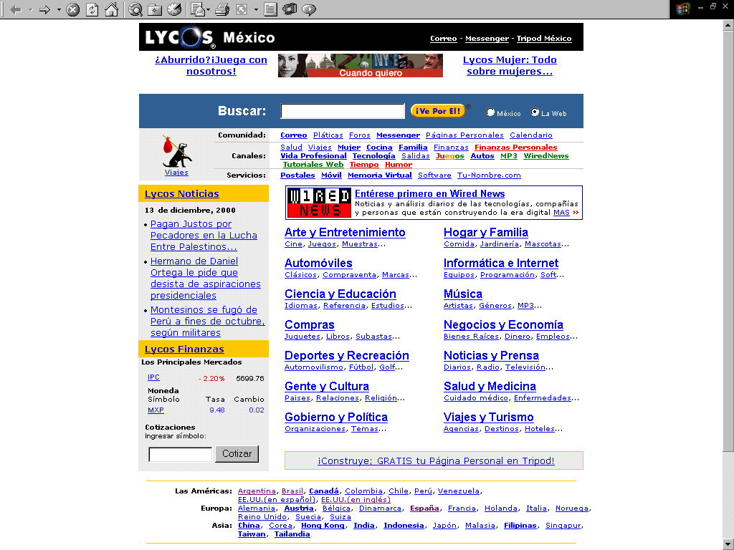

Lycos Brazil

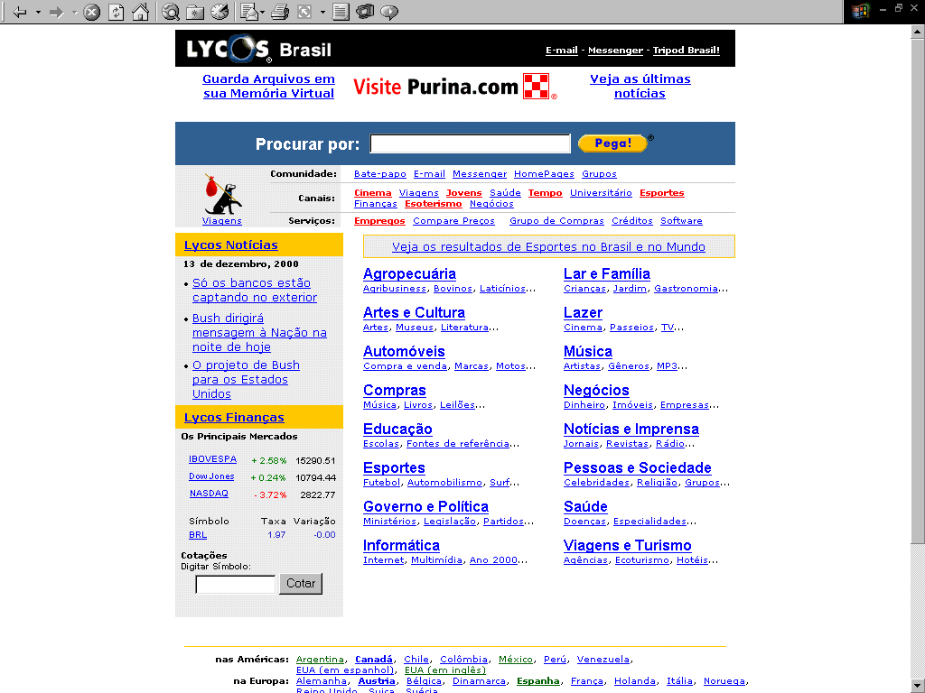
Exhibit 5

Terra Mexico

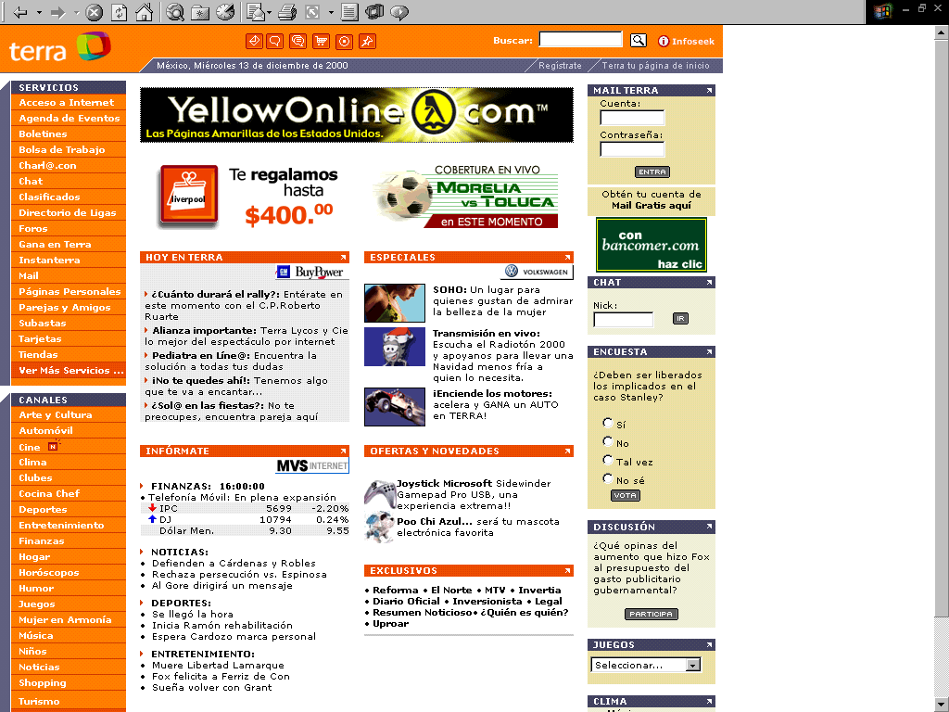

Terra Brazil

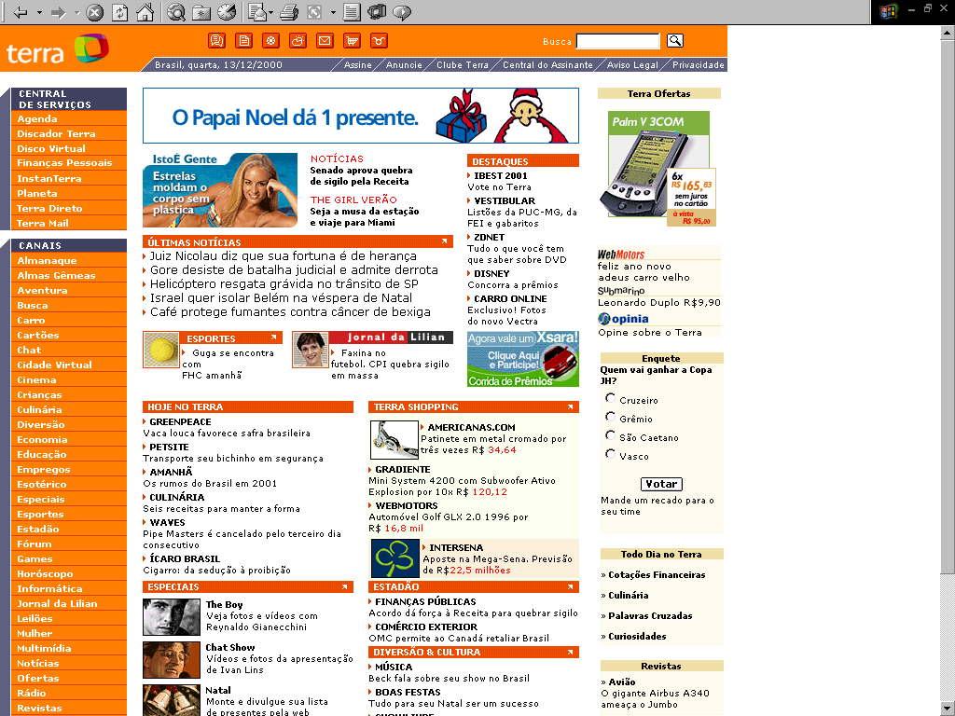

- This case was prepared by Sebastian Pereira. The case was written as a basis for class discussion rather than to illustrate effective or ineffective handling of an administrative situation. Copyright c 2000 by the Massachusetts Institute of Technology Sloan School of Management
The exchange rate dollar/euro as of December, 14 is 0.887

