Kozmo (.com)

(For case discussion in 15.823 on April 9, 2001
with Yong Kang, President & Co-Founder, Kozmo.com)

“Think about all the errands you run on a regular basis, to the video store, the bookstore, the convenience store, the office supply store.… We eliminate all those errands. Being part of your lifestyle is what Kozmo is, where you depend on us for all your various basic needs.”
- Joseph Park
Co-Founder, Kozmo.com

The Company
Kozmo.com delivers videos, DVDs, CDs, books, and convenience items (snacks, magazines, toiletries, household products, flowers, beers etc.) to consumers within an hour, with no delivery charge and no order minimum. The service is currently available in nine cities (Atlanta, Boston, Chicago, Los Angeles, New York, San Francisco, Seattle, Portland and Washington D.C. -see Exhibit 1 and 2 for web page, dates launched and investors). Kozmo plans to be in more than 35 cities in the U.S. by the end of 2002. In 1999, the number of customers registered on the web site grew at a compounded monthly rate of approximately 30%. But the total number of users has remained steady in 2000.

Joseph Park and Yong Kang left their jobs on Wall Street to found Kozmo in 1997, when Joe first ordered a book from Amazon.com and found that it did not fulfill his desire to have the book on the same day. Joe and Yong had been friends since they were roommates as undergraduates at New York University. With a handful of bike couriers delivering goods ordered online by New Yorkers, Kozmo has grown into an army of "Kozmonauts" that serves major cities. In 1999 Kozmo hired several experienced executives from AT&T, Coca-Cola, FedEx, and UPS to round out its senior management team (see Exhibit 3).

In 1999, Kozmo lost $27 million on $3.5 million in revenues, with delivery costs running at $3.3 million. It revenues for financial year 2000 were $30m with a net loss of $120m with delivery costs of $35 m. Its customer acquisition cost has gone down dramatically from $72 per customer in early 1999 to around $50 in late 2000. Current customer acquisition costs are at $25 per customer. From a model of 100% revenues coming from B2C clients in 2000, Kozmo expects revenue diversification –- 75% from retailers, 25% from its B2B operations and 2% from advertising – in 2001 to help its overall gross margins. Current B2B categories are in the areas of Office Supplies (consumables, software, printer cartridges, digital cameras), Travel as well as logistics pertaining to distributors, manufacturers etc. The company closed a $28 million first round with Flatiron Partners in 1999. It has also raised over $130 million from institutional investors including Chase Capital Partners and Softbank Ventures. In March 2000 Amazon.com invested $60 million in Kozmo.com and became the largest stakeholder in Kozmo with a 31% stake on a fully loaded basis (including warrants). As part of the deal, Amazon.com has struck a nonexclusive, three-year alliance to offer its customers a one-hour delivery option, powered by Kozmo.com. The company had filed to go public in late May 2000 (See Exhibit 3 for selected sections of its S-1 filing with SEC) for an expected valuation of $1.2 - $1.5 billion.

"Convenience stores command a premium for providing quick access to last-minute purchases, so why charge a discount for the ultimate convenience of home delivery?"- Evie Black Dykema, an analyst with Forrester Research. The company withdrew its IPO in August 2000 and has been trimming its workforce (refer to optional reading “Kozmo postpones IPO, lays off 24 employees” in Exhibit 4). Kozmo.com shut down its Houston and San Diego operations in 2001, citing lack of demand. Kozmo has announced three layoff’s trimming around 10% of its workforce and has been able to considerably trim its operating and acquisition costs. Kozmo’s product pricing compares on food items, videos, drugs and other items compares well with convenience stores and discount pharmaceutical i.e., CVS, Rite-Aid, Blockbuster. In December 2000, Kozmo introduced a $2 delivery charge on all orders after 3 p.m. and has imposed a minimum order of size of $5 as of summer 2000. With Gerardo Burdo replacing Joseph Park as the CEO in 2000, Kozmo has shifted its focus from building a strong brand to maximizing operational efficiency to help attract and retain B2B and B2C customers at lower cost.

Exhibit 4 contains several suggested press articles on Kozmo and its market space with additional optional readings in Exhibit 5.

The Business Model
Kozmo.com focuses on selling frequently purchased high margin items with well-known brand names. Additionally, it has initiated a business-to-business service to enable select retailers to provide their customers with an expedited delivery option on a fee-for-service basis through Kozmo’s distribution networks.

Kozmo serves each of its markets from one or more distribution centers (DC). DC’s are approximately 10,000 square feet in size and are located primarily in low-rent areas with access to key thoroughfares. The size of DC’s provides capacity to expand product offerings in existing markets. Kozmo.com solution combines the convenience, time savings, large selection of high quality product information, personalization of catalog, Internet shopping with the immediate gratification of in-store shopping, quality customer service, efficient logistics process and low cost distribution model.

Kozmo.com growth strategy has two main objectives: to be the leading online provider of entertainment, food and convenience products with free delivery in under one hour, and to further enhance the usage of distribution infrastructure by providing select retailers an expedited delivery option. To accomplish these objectives, it intends to:

Expand into new geographic markets;
Exploit rapid delivery infrastructure for business to business transactions;
Build the Kozmo brand;
Build a loyal customer base; and
Establish strategic relationships with key vendors, retailers and other service providers.

Competition
Although no company currently does exactly what Kozmo does, there are several current and potential competitors in the race to own the so-called “last mile” − the final distribution leg linking e-commerce to the customer’s doorstep.

Urbanfetch
This company is the most similar to Kozmo.com− it began within-the-hour delivery of books, CDs, videos, electronics, and food last October, but only in New York City. It has no delivery charge, no order minimum, and a no-tipping policy. Urbanfetch planned to expand its service to four or five other cities in 2000 and was in serious acquisition talks with Kozmo in 3rd Quarter 2000. In October 2000, the online delivery service chopped 160 personnel from its employee roster in an attempt to stay afloat with a new business model that waylays consumer delivery in favor of strictly B2B deliveries renamed Urbanfetch Express.

Webvan (Nasdaq: WBVN) http://www001801.webvan.com/WV/Area/central/default.asp?/
This is a full-service online grocer that currently serves only the San Francisco area, but it expects to be in 15 U.S. markets by the end of next year. It delivers free of charge within a 30-minute window specified by the customer. Webvan has a strategic alliance with Bechtel, the world’s leading engineering-construction company, to build large-scale, state-of-the-art distribution centers across the country. It went public last November (its shares are now trading at less than half of its IPO price). Webvan recently announced that it was closing its operations in Dallas and laying off 220 workers. Webvan’s investors include Benchmark Capital, Softbank, CBS, and Knight-Ridder. Other online grocers that are potential competitors to Kozmo.com include Peapod.com and Homeruns.com.

Sameday.com (formerly Shipper.com)
http://sameday.com/
This company offers same-day delivery of consumer goods (including electronics, books, CDs, videos, and toys) in the greater Los Angeles area. It also provides same-day fulfillment and delivery services to e-commerce companies. Based in City of Industry, California, Sameday.com is an Idealab! Company that is backed by Accel Partners.

PDQuick.com (formerly Pink Dot.com)
http://www.pdquick.com/
Pink Dot changed its name to PDQuick in September 2000. Pink Dot started as a convenience store delivering packaged and prepared foods. It started taking orders online in 1997, although about 75 percent of its orders still come in over the phone. This firm delivers groceries, baked goods, sandwiches, liquor, and household goods in about 30 minutes for a delivery fee of $2.99 and has no minimum order requirement. The web site is arranged under four main categories – Kitchen, Market, Drugstore, Liquor & Tobacco. It has free delivery for internet orders over $30. (Refer to “Web quick-delivery companies hit bumps” in Required Readings for additional information)

Homedelivery.com
http://www.homedelivery.com/
This New York-based firm teams up with local merchants to deliver groceries, pet supplies, toiletries, flowers, and dry cleaning to the consumer’s home or office. By bringing together merchants, consumers, strategic partners, product manufacturers and distributors, Homedelivery.com is trying to create an extensive local merchant network in the world, through which established merchants do business on-line with multiple opportunities to reach millions of consumers. Delivery fees and time to delivery vary based on merchant.

Also UPS with its one-hour express is in direct threat to Kozmo on B2B side. The fact that UPS has an extensive package network, full array of back-end logistical services like inventory and warehouse management to e-commerce companies makes them a formidable competitor.

Partnerships
In order to increase distribution, build its brand, and expand into the B2B market, Kozmo.com has aggressively pursued two types of partnerships marketing/co-branding and financial: Some of the key partnerships include: Financial - Amazon.com (March 2000), DreamWorks International Distribution L.L.C., Twentieth Century Fox Home Entertainment and Universal Studios Home Video (September 2000); Marketing - Starbucks, Ticketmaster Online-CitySearch, Balducci Pasta (August 2000) and Zagat Survey (October 2000)

Amazon.com (Nasdaq: AMZN)
On March 20, 2000, Kozmo.com announced a three-year deal to deliver some of Amazon’s books, music, and toys ordered online to customers in cities, which it serves. Beginning in the latter half of this year, Amazon customers will have a Kozmo-branded same-day delivery option for many of its most popular items. The same-day service will be priced at an average of $10 per order, comparable to next-day delivery by FedEx or UPS. Kozmo will keep the entire delivery fee, while Amazon will earn the entire revenue from the order. As part of this deal, Amazon invested $60 million in Kozmo and received the option to buy more shares.
This deal catapults Kozmo into the B2B market-space. Kozmo says that it expects to do more deals of this kind. It forecasts that, by the end of the year, as much as 20% of its revenues will be from its B2B business.

Universal Studios (www.universalstudios.com)
In September 21, 2000 Kozmo.com, announced an agreement with Universal Studios Home Video to purchase DVD and VHS films directly from Universal. Kozmo and Universal Studios Home Video will also work jointly to promote Universal home video releases to Kozmo's 300,000 customers.

Starbucks Coffee Company (Nasdaq: SBUX)
In February, 2000 Kozmo announced an agreement with Starbucks, under which Kozmo will pay Starbucks $150 million over five years to place video drop-off boxes in Starbucks stores within Kozmo’s coverage area. Starbucks will also place Kozmo’s logo on its cups and napkins and train its service staff to handle questions about and promote Kozmo. This deal marks the first time that Starbucks will allow another brand to be promoted inside its stores. With 2,500 stores throughout the U.S., Starbucks will help Kozmo expand its service into new cities.

Ticketmaster Online-CitySearch (Nasdaq: TMCS)
Under this deal announced in January 2000 Kozmo will be the sole under-one-hour delivery service for the CitySearch network of city guides. In return, Ticketmaster Online-CitySearch will become the exclusive provider of local arts and entertainment content on a co-branded site, where users can order from Kozmo. CitySearch currently offers guides to 47 U.S. and international cities.

The Issue
Although Kozmo has many very satisfied and loyal customers, critics of the service believe that Kozmo will not be profitable with its current business model. Kozmo expects to turn profitable in the fourth quarter of 2002. However, it says that it will move towards profitability by:
- Increasing order efficiency through efficient operations,
- Increasing average dollar amount per order, and
- Increasing gross margins.

Order efficiency can be defined as the number of orders per courier per hour (or “courier-hour”). Currently, Kozmo makes about 3 deliveries per courier-hour during its peak hours with an average order size of $12. It says that it will break even if it can reach 3-1/2 deliveries per courier-hour and boost the average order size to $15. FedEx and UPS currently make about 12-13 deliveries per courier-hour. Kozmo believes that it can easily reach 4-5 deliveries per courier-hour as it improves its logistics and achieves more density in its cities. In addition, Kozmo has recently added to its product line higher-ticket, higher-margin items such as DVD players, which it hopes will boost its average order size. In addition, it plans to grow its B2B business, in which its gross margins are 100% compared to current levels of 40%. The company is also aggressively pursuing target internet marketing using software from Ephipany.com.

Can Kozmo survive with its current business model ?
- How can they be more profitable (increase order size, expand product categories, use CRM tools to increase attraction and retention)?
- Should Kozmo go multi channel (catalogues/call centers)?
- Where are growth opportunities (B2B, International, smaller cities, partner) and which should they pursue?
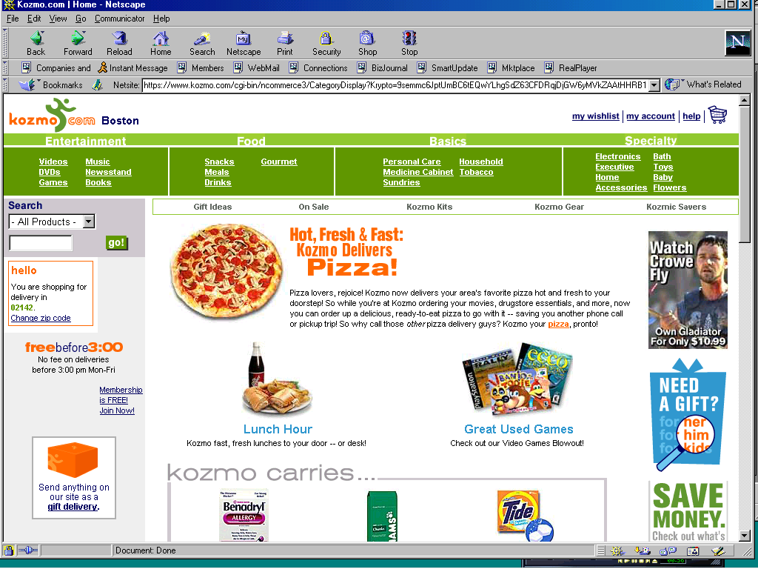
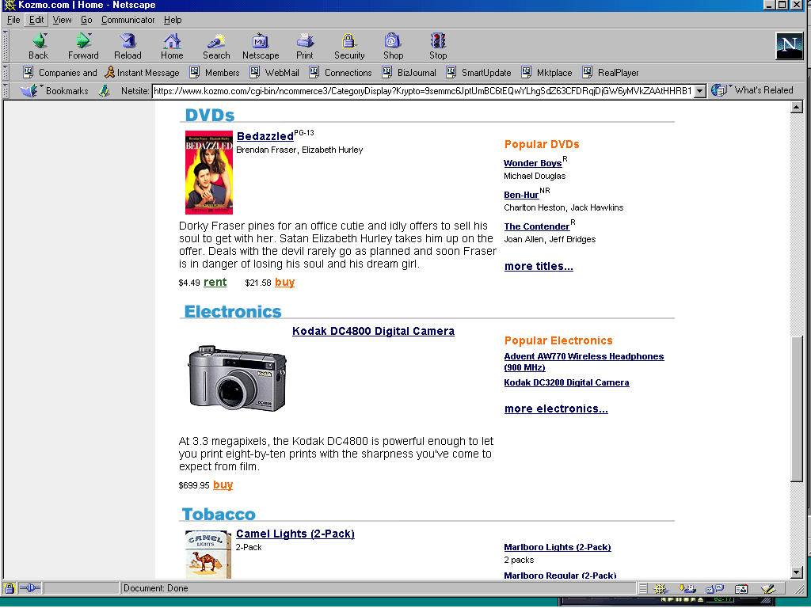
Exhibit 1: Kozmo web site
Exhibit 2: Cities of Operation and Launch Dates

The following are the markets in which Kozmo operates and the dates on which it launched in those cities:

Date Operations
Kozmo Market Commenced

New York City March 1998
Seattle June 1999
San Francisco September 1999
Boston September 1999
Washington, D.C. November 1999
Los Angeles February 2000
Chicago March 2000
Atlanta April 2000
Portland May 2000
SanDiego April 2000 – Closed, Feb. 2001
Houston April 2000 – Closed, Feb. 2001

Coverage

Chicago: Andersonville, Edgewater, Lincoln Square, North Park, Ravenswood,
Rogers Park, Uptown
(zip codes 60625, 60640, 60659, 60660)

Los Angeles: Alhambra, El Sereno, Glassell Park, Lincoln Heights, Montecito
Heights, Silver Lake
(zip codes 90026, 90031, 90032, 90065, 91803)

Portland: Airport, Maywood Park, Milwaukie, Mt. Scott, Oak Grove, Parkrose,
Russellville, St. Johns
(zip codes 97203, 97216, 97218, 97220, 97222, 97266)

Washington, D.C.: Capitol Hill, Howard University, Mt. Vernon Square, Navy
Yard, Southwest Waterfront, Stadium/Armory
(zip codes 20001, 20002, 20003, 20024, 20059, 20060)

Investors
Amazon.com, Chase Venture Capital Associates, Columbia TriStar
DreamWorks SKG, Flatiron Partners, Liberty Media, Oak Investment Partners, SOFTBANK Capital Partners, Starbucks Coffee, Twentieth Century Fox, Universal Studios, Warner Bros.
Exhibit 3: Management Team

The directors, executive officers, and senior management of Kozmo.com and their bios follow:

NAME AGE POSITION
---- -------- --------
Joseph Park............. 28 Chief Executive Officer and Chairman of the Board of
Directors
Yong Kang............... 27 President and Director
Gerardo Burdo........... 34 Senior Vice President and Chief Financial Officer
Kenneth Trevathan....... 53 Senior Vice President and Chief Operating Officer
Christopher Shimojima... 44 Senior Vice President and Chief Marketing Officer
William Herald.......... 49 Senior Vice President and Chief Technology Officer
Larry Johnson........... 48 Senior Vice President of International
Scott Evans............. 32 Vice President of Logistics
James Alt............... 33 Vice President of Supply Chain Management
Andrew Resnick.......... 42 Vice President of Corporate Development
Jack Chen (2)........... 33 Director
Hugh Evans (1).......... 31 Director
Gerald Gallagher (2).... 58 Director
Seth Goldstein (1)...... 29 Director
Robert Greene (1)(2).... 39 Director

(1) Member of Audit Committee
(2) Member of Compensation Committee

JOSEPH PARK co-founded Kozmo with Mr. Kang and has served as our chief executive officer and chairman of the board of directors since July 1997. He is currently a board member of Kozmo. From July 1996 to July 1997, Mr. Park served as an analyst in the corporate finance division of Goldman, Sachs & Co., where he was involved in public equity, hybrid and investment grade debt offerings, mergers and acquisitions, and financial advisory work. From June 1994 to June 1996, Mr. Park served as an analyst in the investment research department at Goldman, Sachs & Co., covering the consumer durable goods and packaging industries.

YONG KANG co-founded Kozmo with Mr. Park and has served as our president and a director since July 1997. He was the Vice-Chairman of Kozmo. From July 1996 to July 1997, Mr. Kang was an assistant vice president at Societe Generale in the media and communications group, specializing in senior bank financing, high yield debt and private equity transactions for companies in the broadcasting, cable and entertainment industries. From July 1994 to July 1996, Mr. Kang was a senior analyst in the mergers and acquisitions group of the Toronto-Dominion Bank, specializing in acquisition advisory, private equity and high yield debt transactions for cable, cellular/PCS, paging and broadcasting companies.

GERARDO BURDO has served as our senior vice president and chief financial officer since November 1999. He is currently the President and acting CEO at Kozmo. From 1991 to 1999, Mr. Burdo held various positions at Ethan Allen Inc., most recently as principal financial officer, vice president and treasurer and as a director of Ethan Allen Canada. From 1987 to 1991, Mr. Burdo held various positions at KPMG LLP.

KENNETH TREVATHAN has served as our senior vice president and chief operating officer since November 1999. From 1984 to 1999, Mr. Trevathan held executive positions in various divisions at Federal Express, most recently as managing director of the logistics and electronic commerce operations of its North American operations. Mr. Trevathan currently serves as a member of the board of directors of Dormnow.com.

CHRISTOPHER SHIMOJIMA has served as our senior vice president and chief marketing officer since December 1999. From 1994 to 1999, Mr. Shimojima held various positions at AT&T, including vice president and general manager of the 10-10-345 Lucky Dog business and vice president of national retention marketing. From 1992 to 1994, Mr. Shimojima was the director of brand strategy at PepsiCo.

WILLIAM HERALD has served as our senior vice president and chief technology officer since February 2000. From 1996 to 2000, Mr. Herald served as a vice president and chief information officer of the Coca-Cola Company. From 1988 to 1996, he was a partner at Ernst & Young and became the national director for the firm's Center for Technology Enablement.

LARRY JOHNSON has served as our senior vice president of international since February 2000. From 1993 to 2000, Mr. Johnson was the vice president of franchising in the international division of Toys 'R' Us. From 1991 to 1993, he was a director of merchandise planning and allocation at Limited Corporation. From 1987 to 1991, Mr. Johnson was a division vice president in various merchandising capacities at Carter Hawley Hale.

SCOTT EVANS has served as our vice president of logistics since August 1999. From 1990 to 1999, Mr. Evans held various positions at United Parcel Service including industrial engineering manager, financial services manager, corporate strategic operations manager and operations supervisor.

JAMES ALT has served as our vice president of supply chain management since October 1999. From 1998 to 1999, Mr. Alt was a management consultant at Ernst & Young. From 1989 to 1996, he held various corporate positions at Target. Mr. Alt currently serves as a member of the board of directors of Autoprof.com.

ANDREW RESNICK has served as our vice president of corporate development since October 1999. From 1994 to 1999, Mr. Resnick served as executive vice president of operations and marketing for Timothy's World Coffee. From 1990 to 1994, he was a regional director of operations for Blockbuster Video.

SELECTED FINANCIAL DATA

The selected balance sheet data as of December 31, 1998 and 1999 and the selected statement of operations data for the period from April 17, 1997 (inception) to December 31, 1997 and the years ended December 31, 1998 and 1999 have been derived from our audited financial statements included elsewhere in this prospectus. The selected balance sheet data as of December 31, 1997 has been derived from our audited financial statements not included in this prospectus. Our historical results are not indicative of the results to be expected in the future. You should read these selected financial data in conjunction with "Management's Discussion and Analysis of Financial Condition and Results of Operations" and our financial statements and the related notes included elsewhere in this prospectus.

PERIOD FROM YEAR ENDED
APRIL 17, 1997 DECEMBER 31,
(INCEPTION) TO ---------------------------
DECEMBER 31, 1997 1998 1999 2000
----------------- ---------- ---------- -----------
(IN THOUSANDS, EXCEPT SHARE AND PER SHARE DATA)
STATEMENT OF OPERATIONS DATA:
Revenues:

Rental....................................... $ -- $ 108 $ 1,706 $ *****
Product sales................................ -- 47 1,803 *****
---------- ---------- ---------- ----------
Total revenues............................. -- 155 3,509 30,000
---------- ---------- ---------- ----------

Costs of revenues:

Cost of rental............................... -- 14 671 *****
Cost of product sales........................ -- 21 1,326 *****
---------- ---------- ---------- ----------
Total costs of revenues.................... -- 35 1,997 *****
---------- ---------- ---------- ----------

Gross profit............................... -- 120 1,512 *****

Operating expenses:

Marketing and sales.......................... -- 117 10,252 *****
Product development.......................... -- 49 1,964 *****
General and administrative................... 118 674 11,551 *****
Delivery..................................... -- 66 3,265 35,000
Depreciation and amortization................ -- 24 801 *****
Non-cash compensation........................ -- 3 208 *****
---------- ---------- ---------- ----------
Total operating expenses................... 118 933 28,041 *****
---------- ---------- ---------- ----------

Loss from operations........................... (118) (813) (26,529) *****
Interest income, net........................... -- -- 159 *****
---------- ---------- ---------- ----------
Net loss....................................... (118) (813) (26,370) (120,000)

Dividends and accretion of redemption value on mandatorily
redeemable convertible preferred stock........ (5) (55) (2,589) *****
---------- ---------- ---------- ----------
Net loss attributable to common stockholders..... $ (123) $ (868) $ (28,959) *****
========== ========== ========== ==========
Basic and diluted net loss per common share...... $ (0.01) $ (0.08) $ (2.79) *****
========== ========== ========== ==========
Weighted-average shares outstanding used in computing basic
and diluted net loss per common share.......... 10,182,000 10,350,000 10,362,192 *****
========== ========== ========== ==========
Pro forma basic and diluted net loss per common share....... $ (1.29) *****
========== ==========
Weighted-average shares outstanding used in computing pro
forma basic and diluted net loss per common share......... 22,430,968 *****
========== ==========

DECEMBER 31,
-----------------------------------------------
1997 1998 1999 2000
----------------- ---------- ---------- ---------
(IN THOUSANDS)
BALANCE SHEET DATA:
Cash and cash equivalents............................ $ 36 $ 82 $ 88,867 $ *****
Working capital (deficit)............................ 84 (186) 78,378 *****
Total assets......................................... 153 558 102,998 *****
Stockholders' equity (deficit)....................... (23) (909) 88,540 *****

***** - Confidential data not available

Exhibit 4: Required Readings

The following articles are required reading for the case discussion in class:
“Kozmo closes 2 markets, cuts more than 120 jobs”
by Kenneth Li, The Standard (Jan. 8, 2001)
http://www.thestandard.com/article/display/0,1151,21329,00.html
(Reproduced on the following pages)

As it shutters operations in Houston and San Diego, the online delivery service lays of another 5 percent of its staff. - By Kenneth Li

In Houston and San Diego, clicking over to Kozmo.com won't help you anymore.
The one-hour delivery service shut down both markets on Friday, laying off 120
employees, or about 5 percent of its staff.

About 10 employees from the company's headquarters in New York were also
affected as the company embarked on another round of cost-cutting measures in
an effort to reach profitability later this year.

Visitors in Houston and San Diego encountered this message on the site last
Friday: "While we wish it weren't so, Kozmo will no longer operate in your area.
Unfortunately, demand did not match our staffing and inventory requirements to
maintain service."

Nationally, the average size of a Kozmo order is about $28. In the markets that
just closed, the average order topped out at $24, say sources in the company.

"Kozmo is no different than a traditional retailer and continually evaluates
underperforming markets," says Kozmo spokesman Matt Higgins. "San Diego and
Houston did not reach a level of traction that other markets have achieved in
similar time frames. We decided to close those markets and focus on our more
mature markets."

The company recently announced another round of financing that has not yet
completed. The latest round is expected to provide a cash infusion of $30 million
from current investors Flatiron Partners , Softbank and Oak Investment Partners.

As part of the new round, the board of directors will be reshuffled, multiple
sources say. Kozmo cofounder Joseph Park will retain a board seat but will no
longer be chairman. Cofounder Yong Kang, who currently still works at the
company, will no longer be vice chairman of the board and will in fact lose his
board seat. In addition, the board is looking to fill two additional seats.
The company has not determined who will be its next chairman.
Exhibit 5: Optional Readings

The following articles are optional reading that may be useful for the case discussion in class:

“Kozmo to announce layoffs, brick-and-mortar strategy”
by Greg Sandoval, ZDNET (Feb 23., 2001)
http://www.zdnet.com/zdnn/stories/news/0,4586,2689343,00.html
“Symbolic Gestures”
by Bruce and Marge Brown, ZDNET (Feb 15., 2001)
http://www.zdnet.com/pcmag/stories/reviews/0,6755,2684550,00.html
“Kozmo postpones IPO, lays off 24 employees”
by Greg Sandoval, ZDNET (June 19, 2000)
http://news.cnet.com/news/0-1007-200-2111054.html
“Web quick-delivery companies hit bumps”
by Julie Landry, Red Herring (May 23, 2000)
http://www.redherring.com/index.asp?layout=story&channel=50000005&doc_id=890010489
“Kozmo.com, Media Company”
by Kenneth Li, The Industry Standard (May 1, 2000)
http://www.thestandard.com/article/display/0,1151,14545,00.html
“Kozmo Seeks to Courier Favor”
by Alec Appelbaum, SmartMoney (Mar. 29, 2000)
http://www.smartmoney.com/smt/markets/news/index.cfm?story=200003293
“Kozmo.com, Media Company”
by Kenneth Li, The Industry Standard (May 1, 2000)
http://www.thestandard.com/article/display/0,1151,14545,00.html
“Kozmo.com Investors Back Boys on Bikes”
by Christopher Byron, The New York Observer (Apr. 3, 2000)
http://www.observer.com/cgi-win/homepage.exe?nyo1/BE040300
“Kozmo.com’s Challenge: Turning the Last Mile into the Green Mile”
by Katherine Hobson and Beth Kwon, TheStreet.com (Mar. 30, 2000)
http://www.thestreet.com/stocks/ipos/909630.html
“The E-Commerce Race to Conquer ‘the Last Mile’”
by Alex Salkever, Business Week (Mar. 16, 2000)
http://www.businessweek.com/bwdaily/dnflash/mar2000/nf00316c.htm

